[***Multi-Level Marketing***](http://1000projects.org/multi-level-marketing-java-project.html)

**Abstract:**

Now a days the e-commerce website and the study type materials are different so difficult to purchase and time taking process. In this Multi-Level Marketing project we are providing both e-commerce and study materials in this project you can buy laptops, mobiles, etc., and also know the study information.

In this Multi-Level Marketing project the admin can login and add products, accepting the user requests and also accept the purchase requests, know the purchase history and add the services. Students who are registered can login and see the products and purchase it, and student can also view the services which are added by the admin.

In this Java project there are two modules

1) Admin

2) User

**Existing System:**

In the existing system the e-commerce website and the study type websites are different so difficult to purchase and time taking process.

**Proposed System:**

In the proposed system the both e-commerce and study type materials are in the same website and the user can easy to select and purchase.

### **UML Diagrams:**

**Use Case Diagram:**

[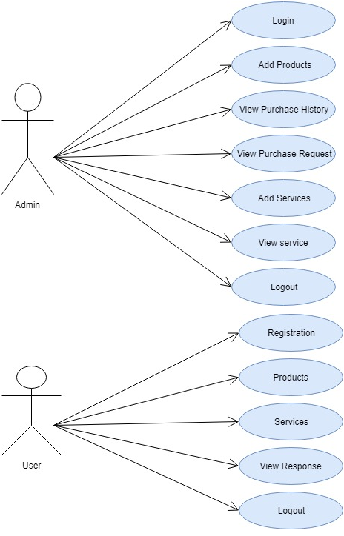](http://1000projects.org/wp-content/uploads/2018/07/Multi-Level-Marketing-Use-Case-Diagram.png)

**Sequence Diagram:**

[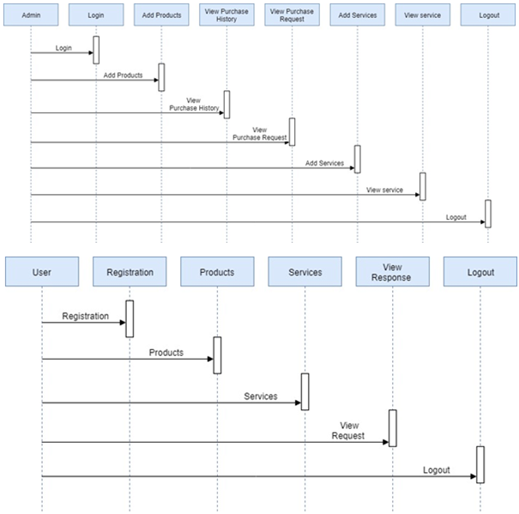](http://1000projects.org/wp-content/uploads/2018/07/Multi-Level-Marketing-Sequence-Diagram.png)

**Activity Diagram:**

[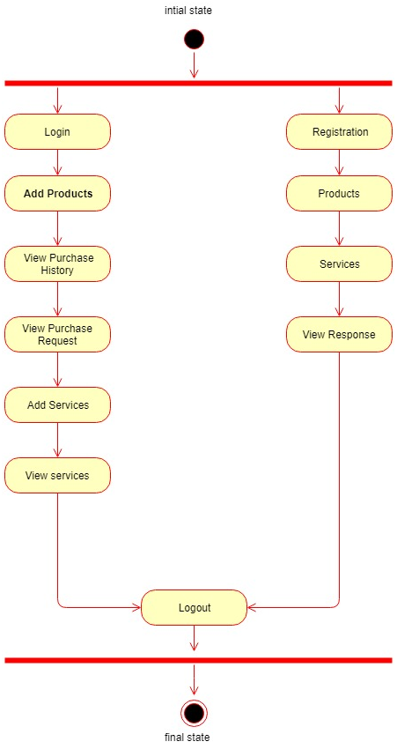](http://1000projects.org/wp-content/uploads/2018/07/Multi-Level-Marketing-Activity-Diagram.png)

**Class Diagram:**

[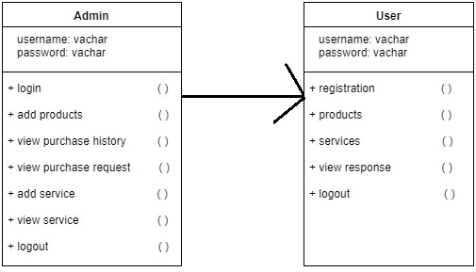](http://1000projects.org/wp-content/uploads/2018/07/Multi-Level-Marketing-Class-Diagram.png)

**Software Requirements:**

* Operating System :  Windows
* Database :  MySQL
* Technology :  Java/j2ee,JDBC,Servlets,JSP
* Web Technologies :  Html ,CSS, Java Script
* Web Server :  Tomcat
* IDE: Eclipse/ Net beans

**All Output Functionalities:**

* Home:
* Admin:
* Admin Home:
* Add Products :
* View Users:
* View Purchase History:
* View Purchase Requests:
* Add Services:
* View Services :
* Registration:
* User Login:
* User Home:
* Products:
* Search Services:
* View Services:
* View Response